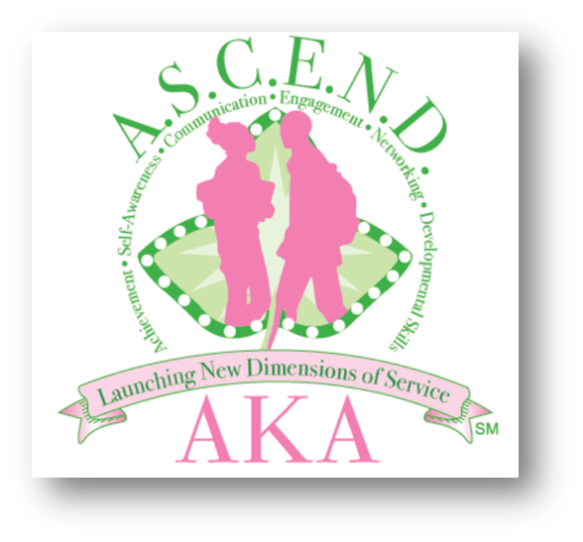

Program Criteria
- The program is open to high school female and male students in grades 9-12.
- Applicants must be currently enrolled in grades 9-12 and in good standing.
- Applications must maintain a C grade point average.
- Applicants must submit a letter of recommendation from a counselor, teacher or community leader.
- Applicants should submit a typed personal statement (not to exceed 500 words) that articulates why he or she wants to join the ASCEND program.
- Applicants must agree to follow the guidelines outlined in the Code of Conduct while participating in the program.
- Applicants must submit a completed parental/legal guardian consent form, signed by the parent/legal guardian and the student.

